

Modular Computer Vision System

Prepared for
Dr/ Mahmoud Gamal
Professor, Faculty of Computing And
Data science Alexandria university

By

Name | ID
Mesk Khaled | 23011537
Shahd Fawzy | 23012087
Ahmed Mohamed Shaaban | 23011213
Moaaz Salama | 23012085

May
2026

Introduction
- This project develops a modular computer vision system for image processing and enhancement.
- The system is designed in a Jupyter notebook using Python and common computer vision libraries.
- The main objective is to create reusable processing steps that can be applied to different images and extended to future tasks.
- The project focuses on combining classical image processing techniques such as color masking, sharpening, blurring, and blending.
- The overall workflow is built to be simple, flexible, and easy to modify for additional computer vision experiments.

Project Aim
- Detect and enhance specific objects in an image based on their color.
- Reduce the visual impact of the background so the target object stands out more clearly.
- Keep the implementation modular so that each processing step can be reused later.
- Produce clear visual output that shows the original image, the mask, and the final enhanced result.

Task 1: Selective Object Enhancement
- Task Description
- The first task identifies regions in an image that match a chosen target color.
- The selected region is enhanced while the rest of the image is softened.
- The output is displayed as a triptych:
  - Original image
  - Color mask
  - Enhanced image
- Method Used
- The input image is loaded from the project image folder.
- The image is converted from BGR to HSV color space for better color-based segmentation.
- A predefined HSV range is used to detect the target color.
- A binary mask is created from the detected color region.
- Morphological operations are applied to clean noise and improve mask quality.
- Gaussian blur is used to soften the mask edges and create a smoother transition.
- The target region is sharpened to increase detail.
- Saturation is boosted to make the selected object more vivid.
- The background is blurred to reduce distraction.
- The final image is created by blending the enhanced object with the blurred background.
- Implemented Functions
- SelectiveEnhancementConfig
  - Stores the enhancement parameters.
  - Includes settings for blur size, sharpening amount, mask smoothing, and saturation boost.
- build_color_mask()
  - Creates a mask for the selected color.
  - Uses HSV thresholding, morphological filtering, and Gaussian blur.
- sharpen_image()
  - Sharpens the selected region using an unsharp masking approach.
- boost_saturation()
  - Increases the saturation of the target region to make the object stand out more.
- selective_object_enhancement()
  - Combines masking, sharpening, saturation boosting, and blending into one pipeline.
- show_triptych()
  - Displays the original image, mask, and final result side by side.
- process_and_display()
  - Loads an image, runs the enhancement pipeline, and shows the output.
- Results
- The system successfully highlights the selected object based on its color.
- The background becomes less dominant due to blurring.
- The final output looks more focused and visually clear.
- The mask visualization helps verify whether the color detection step is working correctly.
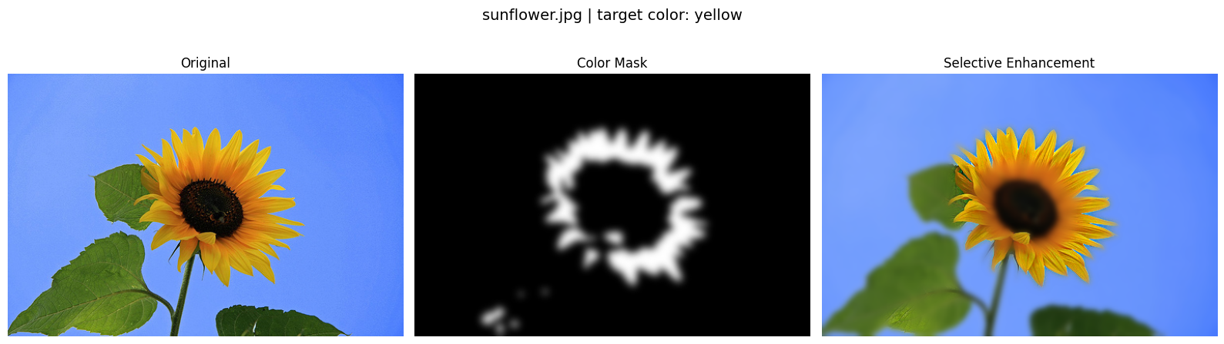
- The enhancement produces smoother and more natural transitions because of soft mask blending.

Task 2: Comparative Study of Sharpening Pipelines for X-Ray Images

1. Task Description
- The goal of this task is to design and evaluate three distinct image enhancement strategies (pipelines) to improve the clarity of X-ray images. X-rays often suffer from low contrast and soft edges, making fine anatomical structures difficult to see. These pipelines aim to accentuate edges and improve local visibility for better diagnostic analysis

2. Implementation Methodology
- In this task, we implemented the pipelines using OpenCV built-in primitives (such as GaussianBlur, Laplacian, and Sobel) as mathematical building blocks. While these low-level functions handle the heavy computation, the overall execution logic and the way these steps are combined remain a custom design.

3. Detailed Pipeline Analysis

- Pipeline 1: Unsharp Masking (Frequency Separation)
  - Logic: It isolates the high-frequency components (edges) by subtracting a blurred version of the image from the original. This "mask" is then amplified and added back to the original image.
  - Goal: To provide balanced sharpening without overly distorting the original pixel distribution.
- Pipeline 2: Laplacian Enhancement (High-Pass Injection)
  - Logic: This pipeline first normalizes local contrast using CLAHE. It then calculates the Laplacian (second-order derivative) to find regions of rapid intensity change. These sharp edges are then "injected" back into the balanced image.
  - Goal: Specifically targeted at enhancing very fine line structures, such as micro-fractures.
- Pipeline 3: Gradient Injection (Sobel + Adaptive Equalization)
  - Logic: It uses Sobel operators to calculate directional gradients (edges). These gradients are merged with a heavily equalized (CLAHE) base using weighted blending.
  - Goal: To maximize the visibility of soft tissue and lung vascularity by forcing high contrast and strong edge definition simultaneously.

4. Quantitative Evaluation
The performance is measured using standard metrics implemented in our library:
- PSNR (Peak Signal-to-Noise Ratio): Measures the fidelity of the enhanced image compared to the original.
- SSIM (Structural Similarity): Ensures that the enhancement has not corrupted the actual anatomical structures.
- Edge Strength Gain: Tracks how much the edge gradients have been amplified.

5. Visual Results and Comparison
As seen in the generated comparison figure, while Pipeline 1 offers the most natural look, Pipeline 3 (Gradient Injection) often provides the highest level of detail for soft tissues, and Pipeline 2 (Laplacian) excels in highlighting dense bone structures.

